HSE Monthly Report – April 2026
Weyland Energy – all sites
Hannah Weber · 06 May 2026 · HSE-RPT-2026-04

1. Headlines
Offshore construction at Harrow Bay started on 7 April with the first monopile. Hours worked rose sharply (Harrow Bay contractors 118,000 h). One medical treatment case at the onshore substation.
Indicator | April | YTD 2026 | 2025
Hours worked | 217,000 | 621,000 | 1,452,000
Lost time injuries | 0 | 1 | 2
Recordable injuries | 1 | 3 | 6
First aid cases | 4 | 18 | –
Near misses | 33 | 121 | 307
Safety observations | 286 | – | –
LTIFR rolling 12 months | 1.23 | – | 1.38
TRIR rolling 12 months | 4.93 | – | 4.13

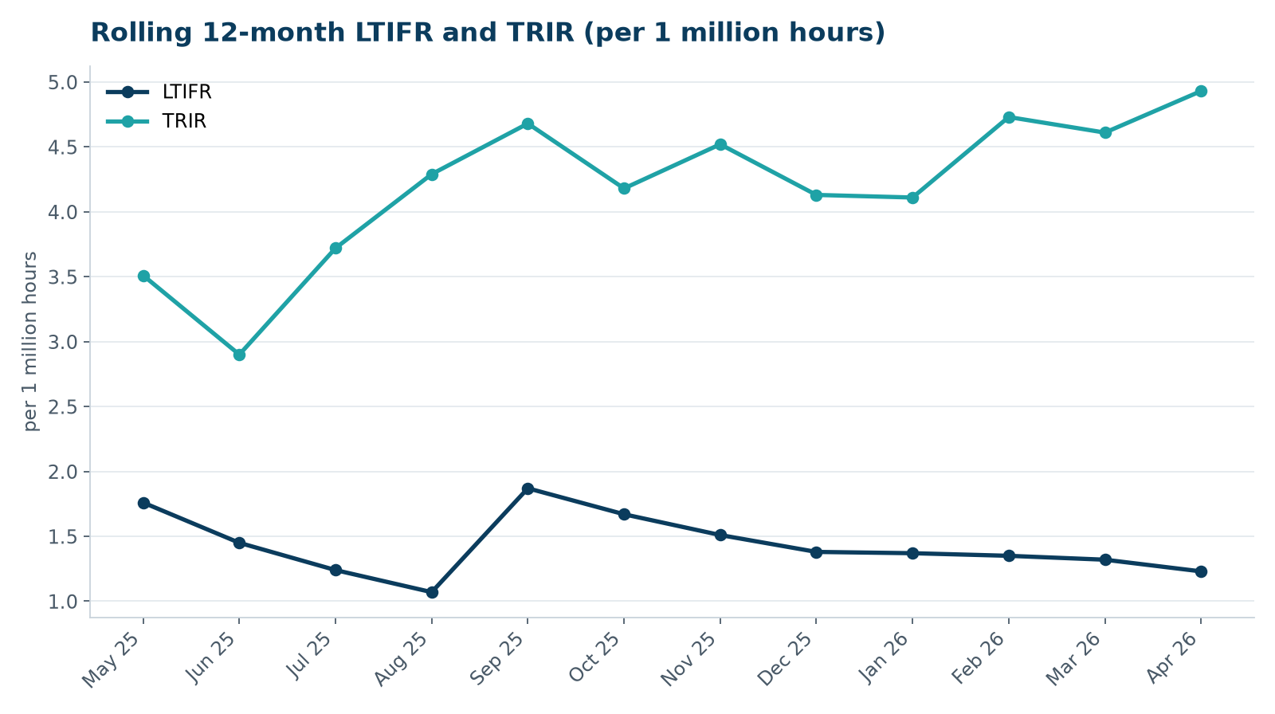

2. Hours by group
Group | Hours | Share
Weyland employees | 66,000 | 30 %
O&M contractors (operating assets) | 33,000 | 15 %
Harrow Bay contractors | 118,000 | 54 %

3. Leading indicators
- Toolbox talks delivered: 112
- Management safety walks: 13 (target 12)
- Inspections of lifting equipment: 71
- Open corrective actions older than 30 days: 4

4. Focus for next month
Contractor onboarding quality: induction checks for new crews on the Harrow Bay vessels.
Hannah Weber, HSE Manager

